Assignment 1
BS6203

Name: Yaoding Chen
Date: 1 Aug 2021
Table of Contents
Task 1 2
Task 2 3
1. Does "a" show the set of genes downstream of IRE1? If not, what is it? 4
2. What is the expected value of "v" if only 3 paths exist? 4
3. What should you expect the value of v to be if > 3 paths exist? 4
4. Do you expect "b" and "c" to be 0? 4
5. Is "x" the common set of genes shared between IRE1 and Perk? 5
6. What is the expected value of "u"? Is it possible to even get "u"? 5
7. Are there situations where regions a b and c are non-empty? 5
8. Does v correspond to triple knock out? 5

Task 1

- Go to Pinterest, and review some data science or machine learning or programming infographics (e.g. https://www.pinterest.com/kourouklides/data-science/?autologin=true or https://www.pinterest.com/gohwils/data-science/)
- Find one (or a few) that you really like (for presentation and content)
- Try to list down why you enjoyed it.

The one I like:

https://www.pinterest.com/pin/523965737870905898/

The reason why:

First, the theme of the infographic is very clear and well-illustrated and supported. It starts with the huge need for data scientists in job markets, then delve into education, i.e. what it needs to be a data scientist, and further mention why there is such a need for data scientists, which ends up with an inspiring conclusion about the bright future of data scientists.

Second, the infographic uses appropriate types of graphs when it needs to illustrate something. For example, when it compares the job market posting of data scientists with the posting of other jobs, it uses a bar chart ranked against other jobs, which also shows a bigger shortage of the job candidates in the market, compared to other jobs. The comparison is more straightforward than the numbers.

Third, the infographic contains all necessary, clear data labels with emphasis on some data labels. This way, I don’t need to search for or guess what are the exact number of the data mentioned according to the graphs. Also, the data labels are all well-chosen to emphasise the supporting data of the themes, e.g. 15,000% increase in job posting between 2011 and 12 is quite impressive to an ordinary reader like me and will be especially attractive.

Fourth, the graphs contains some aesthetics within itself. It is neat, clear, not too messy, and tell a complete story about the career prospect of data science. The colours and the pictures are good-looking, which adds to its attractiveness to readers.

Task 2

The UPR (Unfolded Protein Response) is a cellular stress response that is activated by an accumulation of unfolded or misfolded proteins in the lumen of the endoplasmic reticulum. In this scenario, the UPR has three aims: initially to restore normal function of the cell by halting protein translation, degrading misfolded proteins, and activating the signalling pathways that lead to increasing the production of molecular chaperones involved in protein folding. If these objectives are not achieved within a certain time span or the disruption is prolonged, the UPR aims towards apoptosis. There are 3 pathways that feed into a mechanism known as the UPR. This requires turning on any of 3 potential paths via IRE1, PERK and ATF6. Let us also assume that when turning on these 3 paths, all downstream targets are also all turned on, and there is no suppression.
A student performed a series of knock outs. And for each knock out, measured which genes are still inducible to create the UPR. The results are shown in the Venn diagram here.

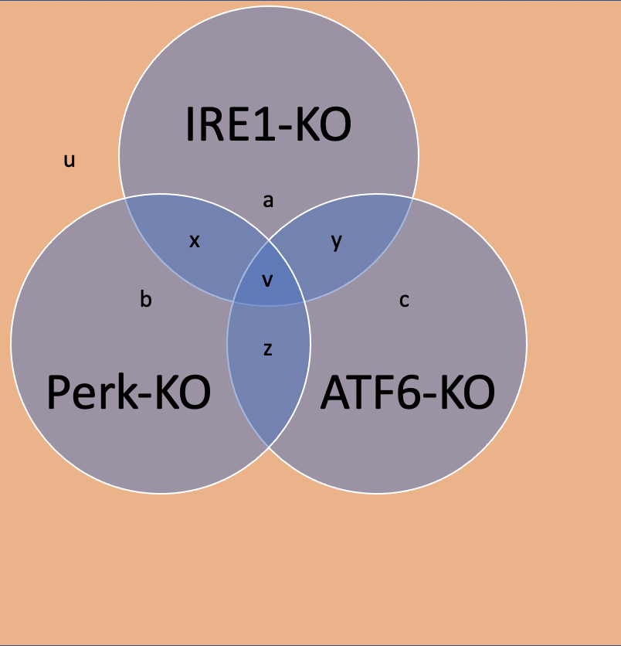

1. Does "a" show the set of genes downstream of IRE1? If not, what is it?
No, “a” does not mean the set of genes downstream of IRE1. Instead, it means genes that can induce UPR independently of IRE1, but it is not found in PERK-KO and ATF6-KO either. It is the combination of downstream genes of PERK and ATF6.

2. What is the expected value of "v" if only 3 paths exist?
Given only 3 pathways existing, if the 3 pathways are independent of each other, which means all of the pathways do not share any downstream genes, then v=0. However, the 3 pathways may share some downstream genes, which means there is convergence amongst the three pathways. In this case, v is non-empty.

3. What should you expect the value of v to be if > 3 paths exist?
The value of v should be non-empty if there are more than 3 pathways.

4. Do you expect "b" and "c" to be 0?
Yes. For example, if b is non-empty, first it means that there are genes that can induce UPR without Perk. Then it also means that it also can induce UPR when ATF6 and IRE1 are knocked out. This means there might be other pathways or the genes are not pathway-specifically induced and might be induced by more than one pathways, i.e. a common downstream to induce UPR, which are different from what we know about the three pathways of UPR.

5. Is "x" the common set of genes shared between IRE1 and Perk?
No, x includes genes regulated by ATF6.

6. What is the expected value of "u"? Is it possible to even get "u"?
If there are only three pathways, then u should be empty. We are unable to know whether such u exists without a priori knowledge, as in that case, all we might manipulate are the known genes within the three known pathways, which are not included in u. So, we have no clue of how such genes in u affect UPR.

7. Are there situations where regions a b and c are non-empty?
Yes, when there are a common downstream of two pathways but not shared with the other pathway. See also Question 4.

8. Does v correspond to triple knock out?
No. The three circles in the Venn’s plot actually means three different knockout experiments, whereas a triple knockout is technically impossible, since simultaneous removal of PERK, IRE1 and ATF6 may cause the cell to be unable to survive.

